

|  |
| --- |
| Sales & Customer Insights Report |
|  |
| 21st Feb  Retail Store  Authored by: Soumyajit Das |



Business Performance Analysis Report

# 

Executive Summary

This report presents a comprehensive analysis of a retail store’s sales data from January 2022 to December 2022, covering a full year of transactions. The store operates through multiple online channels, including Meesho, Flipkart, Amazon, and others, selling a variety of clothing products such as blouses, bottoms, kurtas, ethnic dresses, sarees, and tops to customers across different cities in India.

Purpose of This Report

* Analyze Key Business Metrics – Evaluate sales trends, customer behaviour, and product performance.
* Identify Top-Performing Segments – Highlight high-performing states, age groups, and sales channels.
* Understand Return & Refund Patterns – Examine reasons behind returns and refunds to minimize losses.
* Optimize Business Strategies – Use insights to improve marketing, inventory management, and sales tactics.
* Enhance Customer Retention – Leverage findings to boost customer satisfaction and loyalty.

Key Insights

* March had the highest sales, possibly due to promotions, seasonal demand, or product launches. Further analysis is needed to identify key contributing categories.
* Women dominate the market, accounting for 64% of total sales, highlighting a strong purchasing trend among female customers.
* Maharashtra leads in sales, generating ₹2,990,221 indicating a high customer base and strong market demand.
* Tuesday is the peak sales day, suggesting potential opportunities for targeted promotions or marketing strategies.
* The Set category is the top-selling product, significantly outperforming other categories in total sales.

Introduction

Vrinda Store Data Overview

* The dataset contains annual sales data for the year 2022.
* It includes key business metrics such as order dates, customer demographics (age and gender), product categories, and sales channels.
* Financial details like sales amounts, order statuses, and transaction values are provided.
* It helps analyze sales trends, customer behaviour, product performance, and regional sales distributions.
* Useful for building dashboards and reports to derive actionable business insights.
* Data Set Link - [https://docs.google.com/spreadsheets/d/1N_Aa45UnkPmnwGqNr6oTzvUhb5TKlitM/edit?gid=1081836936#gid=1081836936](https://docs.google.com/spreadsheets/d/1N_Aa45UnkPmnwGqNr6oTzvUhb5TKlitM/edit?gid=1081836936" \l "gid=1081836936)

Objective of the Report

The primary objective of this report is to analyze sales performance, customer behaviour, and product trends using the Vrinda Store dataset. The key goals include:

* Understanding Sales Trends: Identifying peak sales periods, top-performing months, and seasonal fluctuations.
* Customer Behaviour Analysis: Examining purchasing patterns based on gender, age group, and repeat customers.
* Product & Category Performance: Evaluating which product categories generate the highest revenue and have the strongest growth trends.
* Regional Sales Insights: Determining which states and cities contribute the most to sales and have the highest return/refund rates.
* Order & Transaction Analysis: Assessing order fulfilment status, average transaction value, and differences between individual and business purchases.

Tools and Methodologies Used

Tools:

* Python: Used for data cleaning, analysis, and visualization.
* Power BI: Will be used to create an interactive dashboard for business insights.
* MS Word: Used for documenting the report.

Methodologies:

* Exploratory Data Analysis (EDA): Understanding the dataset, handling missing values, and generating insights.
* Data Visualization: Creating charts and graphs to represent sales trends, customer behaviour, and product performance.
* Aggregation & Grouping: Using group-by operations to analyze data at different levels (monthly, category-wise, gender-wise, etc.).
* Comparative Analysis: Evaluating different customer segments, return rates, and order fulfilment trends.

Python Libraries Used:

* pandas – Data manipulation and analysis
* numpy – Numerical computations
* matplotlib – Data visualization
* seaborn – Advanced visualizations
* datetime – Handling date and time data
* plotly – Interactive visualizations
* warnings – Suppressing warnings for cleaner outputs

Data Overview

* Total Transactions: 31,047 (Total orders in the dataset)
* Total Sales Revenue: ₹21,176,377 (INR)
* Total Unique Customers: 28,437
* Time Period Covered: January to December 2022

Challenges Faced During Data Cleaning

1. Inconsistent Gender Labels – The gender column had inconsistencies, such as variations in spelling and case (e.g., "Men" vs. "M"), requiring standardization.
2. State Column Inconsistencies – Some states had duplicate entries due to variations in spelling abbreviations, or case differences (e.g., "Delhi" vs. "New Delhi").

These challenges were addressed to ensure data accuracy and consistency before conducting business analysis

Feature Engineering

1. Age Transformation into Age Groups
   * The raw age data was categorized into groups to simplify customer segmentation and analysis:
     + Teenager (13-19 years)
     + Young Adult (20-29 years)
     + Adult (30-44 years)
     + Middle Age (45-59 years)
     + Senior (60+ years)
   * This transformation helped in understanding purchasing behaviour across different age demographics.
2. Date Column Breakdown
   * The Date column was split into Year, Month, and Day to allow time-based trend analysis:
     + Year – Extracted to analyze yearly growth and performance.
     + Month – Used for identifying seasonal trends and peak sales periods.
     + Day – Helped in analysing weekday vs. weekend sales behaviour.
   * This transformation allowed for better visualization and trend analysis over time.

These feature engineering techniques helped enhance the dataset, making it more structured and meaningful for business insights.

Business Questions and Insights

**Monthly Sales Trend Analysis**

Question: How did sales perform from January to December?

**Overall Trend**

The sales data from January to December 2022 indicate a declining trend over the months. While some months experienced moderate spikes, the overall trajectory showed a steady decline in revenue. This suggests possible seasonality in consumer behaviour or external market influences.

**Peak Sales Month (March)**

March recorded the highest sales at **₹1,928,066**, possibly driven by promotional campaigns, seasonal demand, or new product launches. A deeper analysis is required to identify which product categories contributed the most to this surge in revenue. Understanding these drivers can help replicate the success in other months.

**Lowest Sales Month (December)**

Despite December traditionally being a peak shopping season, sales were the lowest at **₹1,622,033**. Possible reasons for this decline could include a lack of discounts, a shift in consumer spending patterns, or increased competition from rival retailers. Examining competitor strategies and customer preferences during this period may provide insights into improving future performance.

**Visualization**

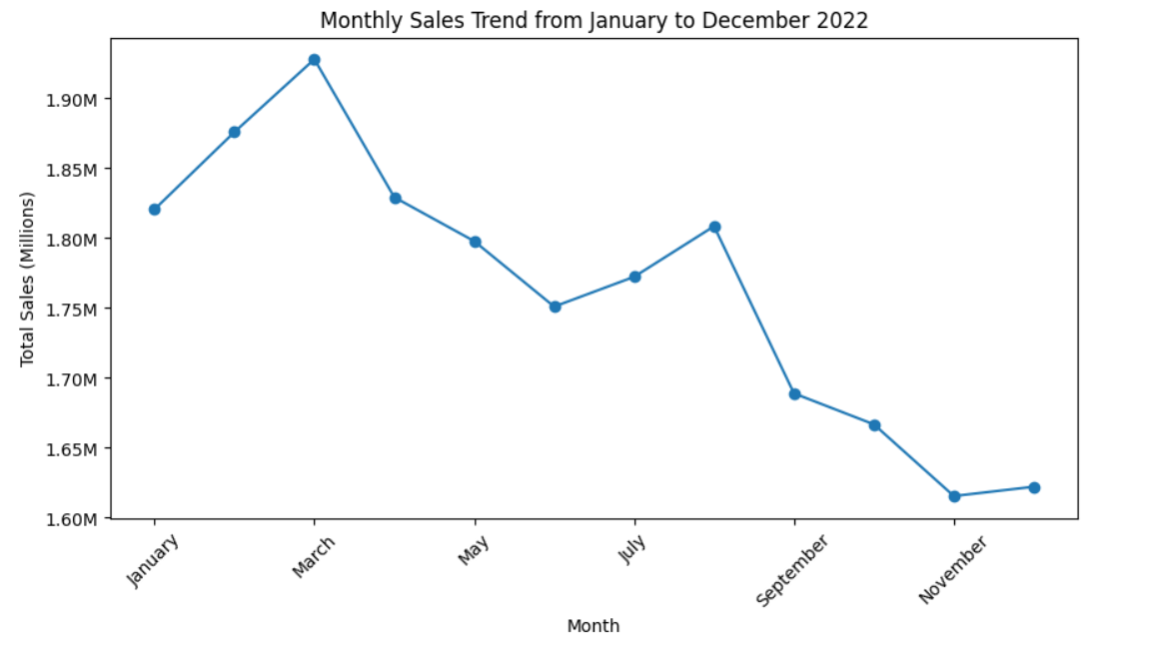

**Gradual Decline in Sales**

The data reveal a steady decline in sales, which may indicate either seasonal influences or a long-term drop in demand. Several external factors could have contributed to this trend, such as changing consumer preferences, pricing strategies, economic conditions, or stronger competition.

**Actionable Insights**

* **Analyze March’s Success:** Identify which categories or promotions contributed to the highest sales and apply similar strategies to other months.
* **Investigate December’s Drop:** Examine competitor marketing strategies and customer behaviour in December to enhance future holiday season campaigns.
* **Channel & Category Analysis:** Conduct deeper analyses on product categories and sales channels to identify underperforming areas and optimize business strategies.

Highest Number of Sales by Weekday

Question: Which weekday has the highest no. of sales?

Top Sales Day - Tuesday:

* Tuesday recorded the highest sales with 3,762,642 INR indicating strong customer activity on this day.
* Possible reasons: Mid-week promotions, targeted discounts, or customer shopping behaviour trends.
* Weekend Sales Performance: Sunday (3,250,793) and Saturday (3,186,984) also had high sales, indicating strong weekend shopping trends.

Lowest Sales Day - Thursday:

* Thursday had the lowest sales at 2,207,368 INR suggesting potential for improvement.
* A detailed analysis of promotional strategies and customer engagement on Thursdays is needed.

Visualization

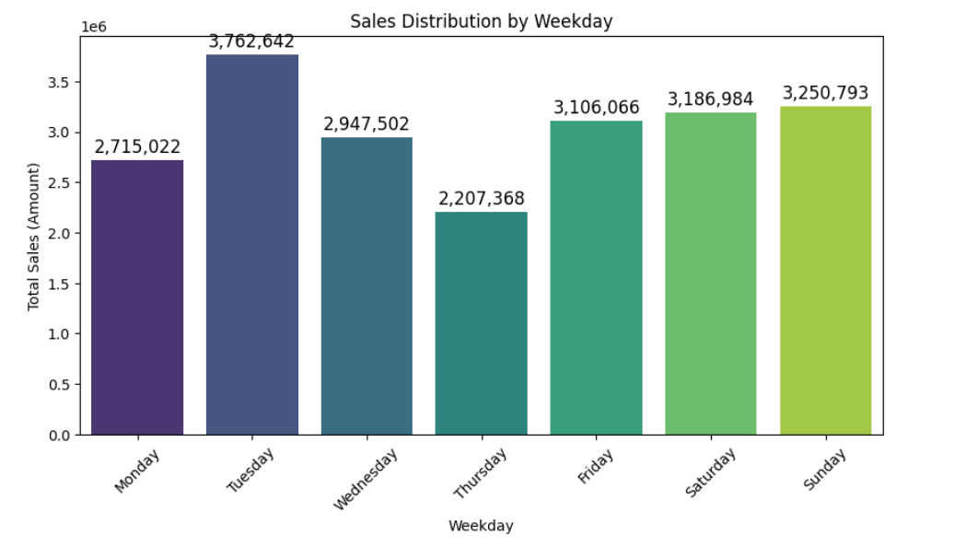

Actionable Insights:

* Leverage Tuesday’s high sales trend by introducing targeted marketing campaigns.
* Investigate Thursday’s performance—potential causes could be low customer engagement, lack of discounts, or weak advertising.

Gender-Based Sales Analysis

Question: Who purchased more Men or Women?

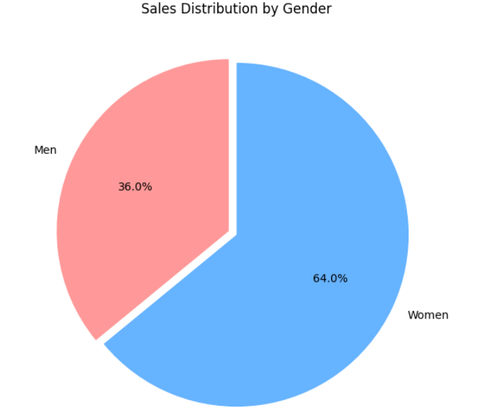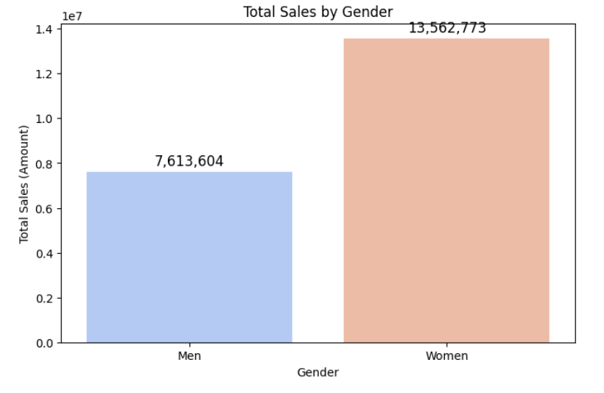

* Women are the Majority Buyers
* 64% of total sales came from female customers, indicating a strong purchasing trend among women.
* Total sales from women: ₹13,562,773
* Men Contribute 36% of Sales
* While men account for a smaller share, their purchases still represent a significant portion.
* Total sales from men: ₹7,613,604
* Key Business Insights
* Targeted promotions should be designed for women, focusing on preferred product categories.
* Men’s engagement can be improved by identifying and promoting categories with higher male interest.

Sales Analysis by Top 10 States

Question: What are the Top 10 States Contributing to Sales?

* Maharashtra Leads the Sales Market
* Total Sales: ₹2,990,221
* Maharashtra tops the list, making it the most profitable region.
* Strong customer base and high market demand present opportunities for further expansion.
* Karnataka & Uttar Pradesh Follow Closely
* Karnataka: ₹2,646,358 (2nd place)
* Uttar Pradesh: ₹2,104,659 (3rd place)
* Both states contribute significantly, offering potential for increased market penetration.
* Southern States Show Strong Performance
* Karnataka, Telangana, Tamil Nadu, and Kerala all feature in the top 10.
* South India’s growing consumer base makes it a prime market for targeted sales strategies.
* Delhi & Haryana Represent North India's Key Markets
* Delhi: ₹1,274,750
* Haryana: ₹813,320
* Urban and industrial demand drive sales in these regions, indicating a strong potential for business-focused marketing.
* West Bengal & Andhra Pradesh Hold Market Share
* West Bengal: ₹922,444
* Andhra Pradesh: ₹918,499
* Consistent sales trends suggest opportunities to strengthen supply chains and implement localized marketing strategies.

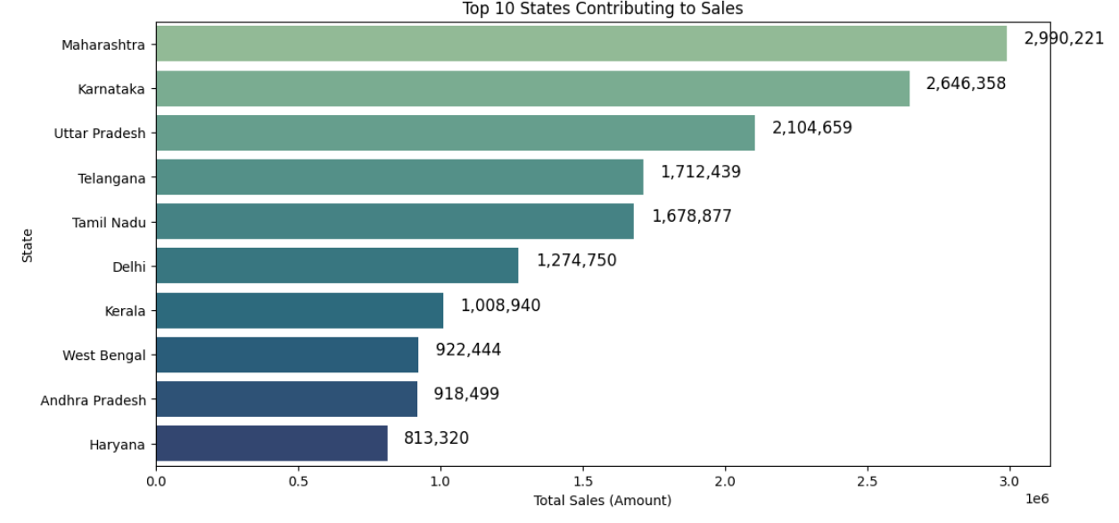

Business Implications

* High ROI Potential: Maharashtra, Karnataka, and Uttar Pradesh are key revenue drivers—investing more in these states can yield higher returns.
* South India Expansion: The rising consumer trend in South India suggests regional marketing strategies and expansion can boost sales.

Order Status Analysis

Question: What is the distribution of order statuses, including delivered, returned, cancelled, and refunded orders?

Key Insights

* High Successful Deliveries (92% Success Rate)
* The majority of orders were delivered successfully, indicating a well-functioning logistics and fulfilment process.
* Returns (3.3%) and Refunds (1.6%) Exist but Are Manageable
* The return rate is within an acceptable range, but further analysis is needed to identify patterns related to specific products, regions, or customer segments.
* Refunds might be tied to product defects, delays, or disputes, requiring root cause analysis for better resolution.
* Cancellations (2.7%) Could Indicate Customer Uncertainty
* A notable number of cancellations may suggest pricing concerns, product availability issues, or order processing delays.
* Studying cancellation trends can help improve the customer experience and reduce drop-offs.
* Refunds (1.6%) Suggest Possible Product Issues
* Refunds are likely due to product quality concerns, late deliveries, or return policies.
* Addressing refund reasons can enhance customer trust and retention.

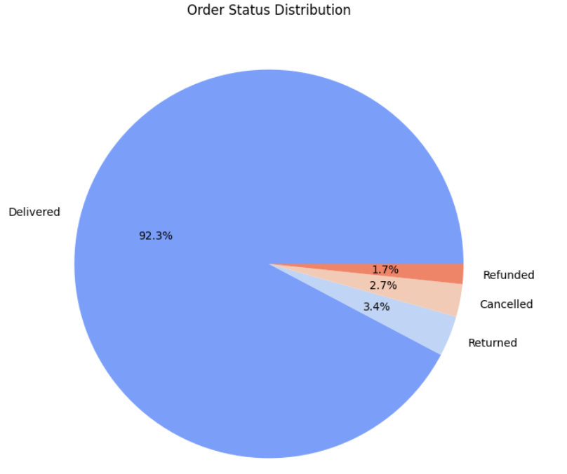

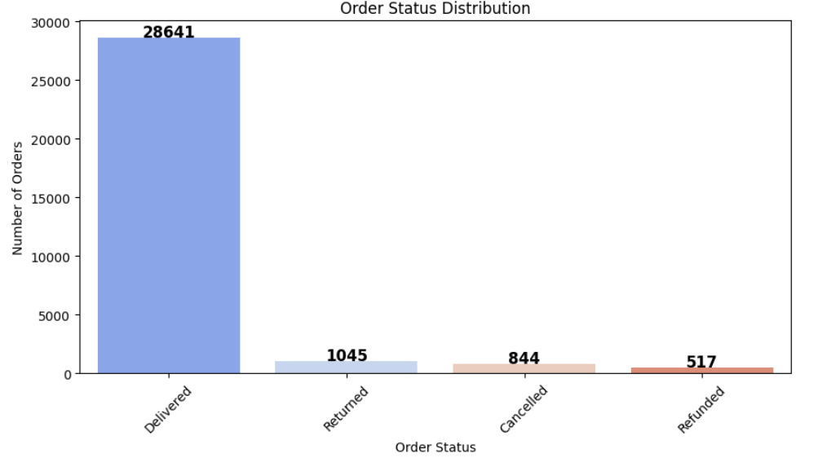

Sales Analysis by Age Group

Question: Which age group contributes the most to total sales revenue?

Key Insights

* Adults (26-40 years) are the top spenders
* Contributed ₹7,989,535 in total sales.
* Likely due to higher purchasing power and financial stability.
* Middle-aged individuals (41-55 years) rank second
* Generated ₹6,781,967 in sales.
* Possibly driven by high-value purchases and repeat buying behaviour.
* Young Adults (19-25 years) show significant spending
* Sales contribution: ₹3,192,082.
* Likely influenced by trends, brand preferences, and online shopping habits.
* Seniors (56+ years) have a lower share
* Contributed ₹2,713,943 in sales.
* Less active in online shopping compared to younger demographics.
* Teenagers (13-18 years) contribute the least
* Total sales: ₹498,850.
* Limited purchasing power due to financial dependence.

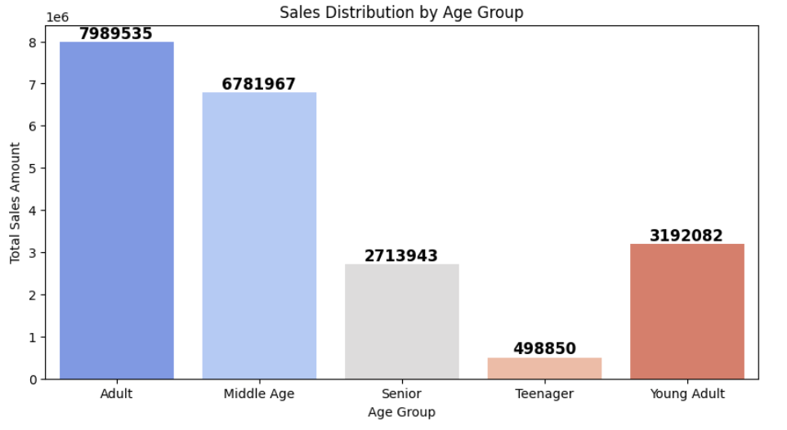

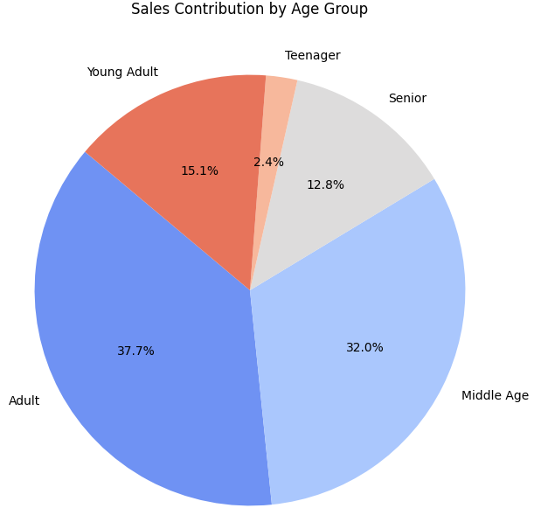

Key Takeaways

* The prime spending groups (26-55 years) contribute over 70% of total sales.
* Teenagers & Seniors contribute the least, likely due to financial dependence or lower interest in online shopping.
* Marketing strategies should focus on Adults & Middle Age groups for maximum revenue generation, while also engaging Young Adults to build long-term customer loyalty.

Gender-Wise Age Group Sales Analysis

Question: How does sales distribution vary across age groups for men and women?

Key Insights

* Women contribute the highest sales across all age groups
* Adult women (26-40 years) lead with ₹5,108,166 in sales.
* Middle-aged women (41-55 years) follow closely with ₹4,348,215.
* Overall, women consistently spend more than men in every age category.
* Men's highest sales come from adults (26-40 years) and Middle Age (41-55 years)
* Adult men contributed ₹2,881,369, the highest among male age groups.
* Middle-aged men generated ₹2,433,752 in sales.
* Seniors (56+ years) contribute significantly but less than younger demographics
* Senior women: ₹1,748,223 | Senior men: ₹965,720.
* Women in this category contribute 1.8x more than men.
* Teenagers and Young Adults contribute the least overall
* Teenager women: ₹330,516 | Teenager men: ₹168,334.
* Young Adult women: ₹2,027,653 | Young Adult men: ₹1,164,429.

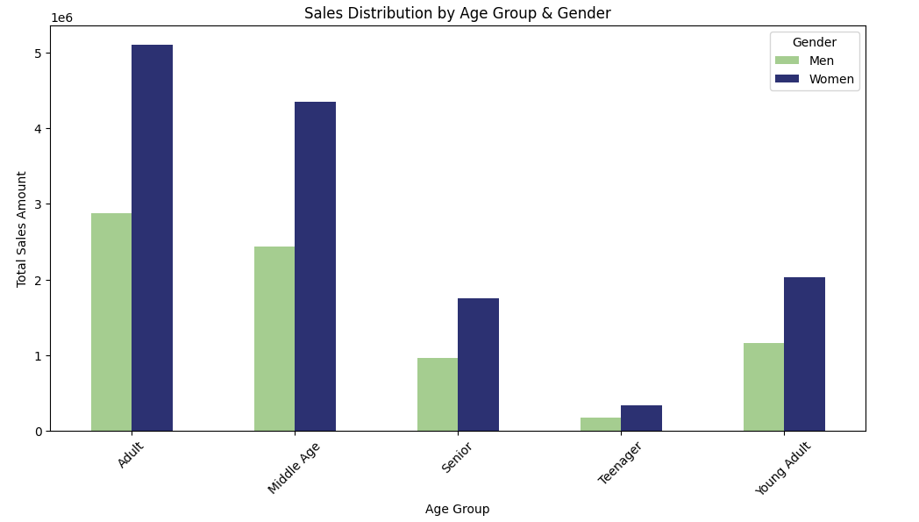

Key Takeaways

* Women consistently spend more across all age groups, making them the dominant consumer segment.
* Adult & Middle Age groups (26-55 years) form the core sales drivers, both for men and women.
* Teenagers & Seniors contribute the least, suggesting that businesses should focus marketing efforts on adults and middle-aged consumers.
* Brands can create targeted promotions for women-focused products while also exploring ways to boost male engagement in key product categories.

Sales Contribution by Channels

Question: What are the Channels which are contributing to the sales?

* Amazon Dominates the Market
* Amazon leads as the highest revenue-generating platform, contributing ₹7,519,933 in total sales. This suggests that Amazon is the most preferred shopping platform among customers.
* Flipkart – A Strong Competitor
* Flipkart ranks second with ₹4,573,301 in sales. While significantly lower than Amazon, it remains a key player in the market.
* Myntra’s Strong Presence in Fashion
* Myntra secures third place with ₹4,941,540 in total sales, indicating a strong presence, especially in fashion and lifestyle shopping.
* Mid-Tier Platforms: Ajio & Nalli
* Ajio contributes ₹1,331,427, playing a moderate role in the market.
* Nalli (₹1,015,329) likely specializes in niche products such as ethnic or traditional wear.
* Meesho’s Budget-Focused Market
* Meesho contributes ₹927,606, which is relatively lower than mainstream platforms like Amazon and Flipkart. This may be due to its focus on budget-conscious and reseller-driven shopping.
* Contribution of Other Platforms
* ‘Others’ account for ₹867,241, representing various smaller e-commerce platforms that still hold market significance.

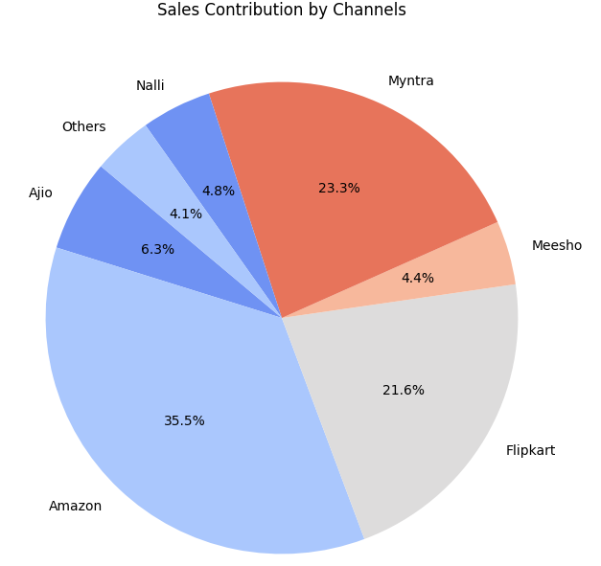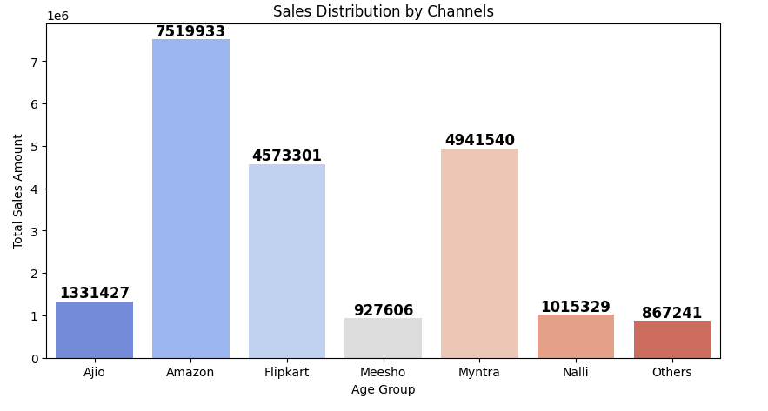

Key Insights & Business Implications

* Amazon dominates the e-commerce space, making it the go-to choice for customers.
* Flipkart and Myntra cater to different audience segments and remain strong competitors.
* Niche platforms like Nalli and Ajio contribute but are still behind bigger players.
* Meesho’s lower sales suggest it targets budget-conscious shoppers, indicating a different customer demographic.

Top Revenue-Generating Cities

Question: Which cities generate the highest revenue?

* Bengaluru – The Sales Leader
* Generates the highest revenue at ₹1,766,657.
* High disposable income and tech-savvy population.
* Strong e-commerce adoption.
* Hyderabad – A Strong Contender
* Total sales of ₹1,370,811.
* Rapidly growing middle-class consumer base.
* Increasing online shopping trends.
* New Delhi – A High-Potential Market
* Revenue of ₹1,162,928.
* Strong demand for fashion and apparel.
* Diverse customer base with high purchasing power.
* Chennai & Mumbai – Steady Contributors
* Chennai: ₹922,887
* Mumbai: ₹917,625
* Slightly lower sales compared to top three cities.
* Local shopping preferences and demographic variations may contribute to differences.

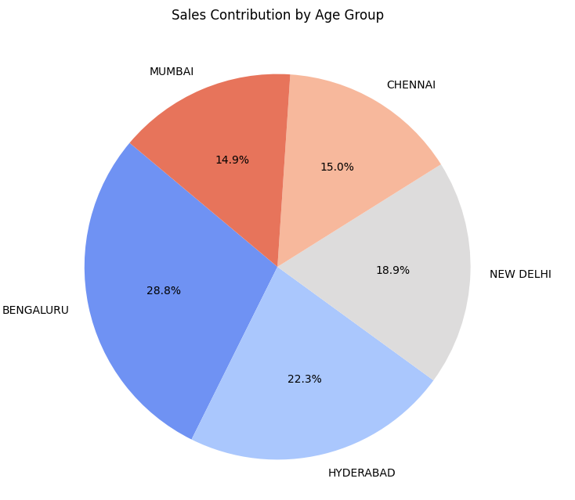

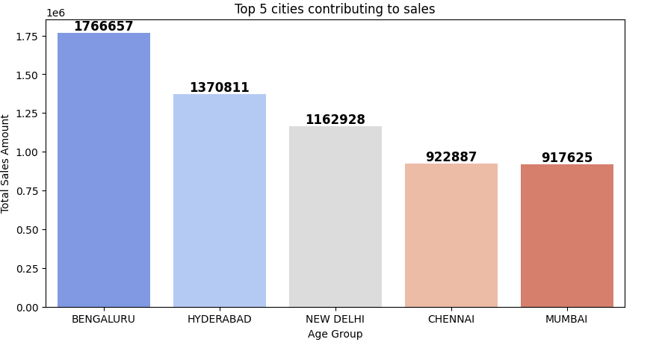

Key Insights & Business Implications

* Metro cities drive the highest sales due to higher internet penetration and purchasing power.
* E-commerce platforms play a crucial role in sustaining revenue growth.
* Targeted marketing strategies in these cities can further boost engagement and sales.

States with the Highest Return Rates

Question: Which state has the highest return rate?

* Chandigarh – Highest Return Rate (7.61%)
* Significant number of product returns compared to total orders.
* Possible reasons: product dissatisfaction, delivery issues, or regional buying behaviour.
* Andaman & Nicobar – High Return Rate (6.94%)
* Returns could be due to logistical challenges in remote locations.
* Product dissatisfaction may also contribute.
* Jammu & Kashmir – Return Rate of 5.14%
* Delivery constraints and regional factors may influence returns.
* Customer preferences and accessibility could be key factors.
* Bihar – Return Rate of 4.82%
* Possible reasons: product quality concerns or mismatched customer expectations.
* Requires further analysis to identify specific issues.
* Dadra and Nagar Haveli – Return Rate of 4.76%
* One of the top regions with frequent returns.
* Could be linked to supply chain challenges or customer buying patterns.

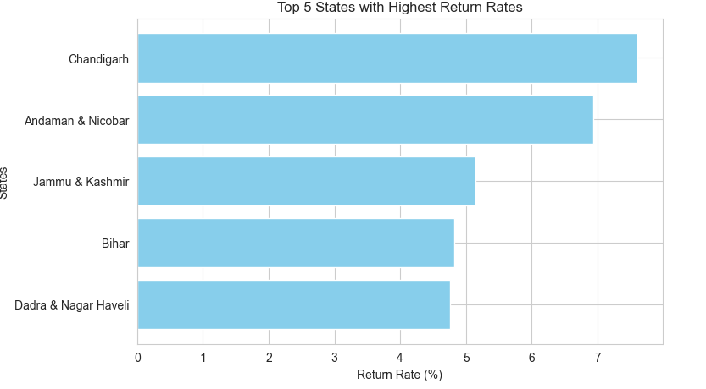

Key Insights & Business Implications

* High return rates may indicate logistical issues, product dissatisfaction, or regional challenges.
* Addressing customer concerns in these states can help reduce return rates.
* Improving quality checks and optimizing delivery services can enhance customer satisfaction.

States with the Highest Refund Rates

Question: Which state has the highest refund rates?

1. Meghalaya – Highest Refund Rate (7.50%)

* Significant proportion of refunded orders.
* Possible reasons: product dissatisfaction, order issues, or logistical challenges.

2. Uttarakhand – Refund Rate of 2.65%

* Relatively high refund rate compared to other states.
* Could be due to delivery delays or mismatched expectations.

3. Goa – Refund Rate of 2.61%

* Refunds may be influenced by customer dissatisfaction or product quality concerns.
* Logistical factors might also contribute.

4. Kerala – Refund Rate of 2.26%

* Possible correlation between returns and refunds.
* Understanding product categories with high refund rates can help address the issue.

5. Chandigarh – Refund Rate of 2.17%

* Previously identified as having a high return rate, leading to refunds.
* Investigating common refund reasons can help improve customer experience.

6. Maharashtra (1.99%), Gujarat (1.98%), and Nagaland (1.96%)

* These states also show notable refund rates.
* Requires further analysis to determine if refunds are due to product issues, logistics, or policy-related factors.

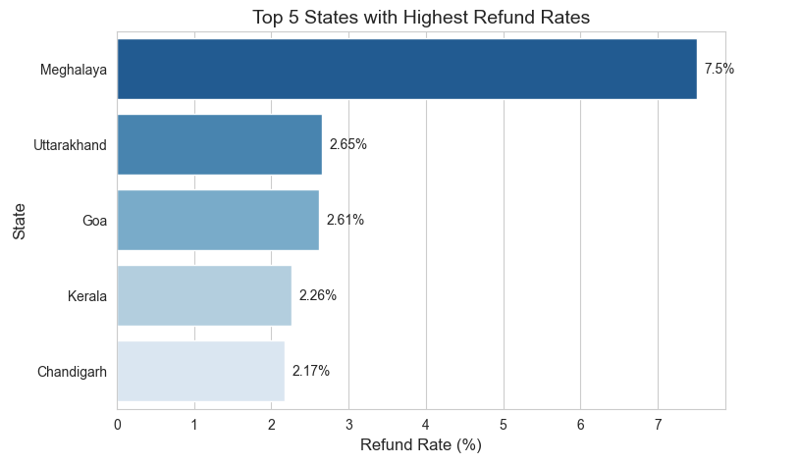

Key Insights & Business Implications

* Meghalaya stands out with the highest refund rate, needing immediate attention.
* Other states with moderate to high refund rates may require improved quality control and better customer communication.
* Analysing refund trends can help refine product offerings and reduce unnecessary refunds.

Highest Order Price and Category

Question: Which is the highest order price in which category does it belong?

* Highest Order Price: ₹3,036
* 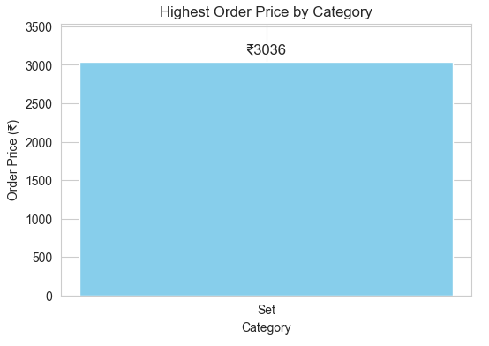Category: Set

Lowest Order Price and Category

Question: Which is the lowest order price in which category does it belong?

* Lowest Order Price: ₹229
* 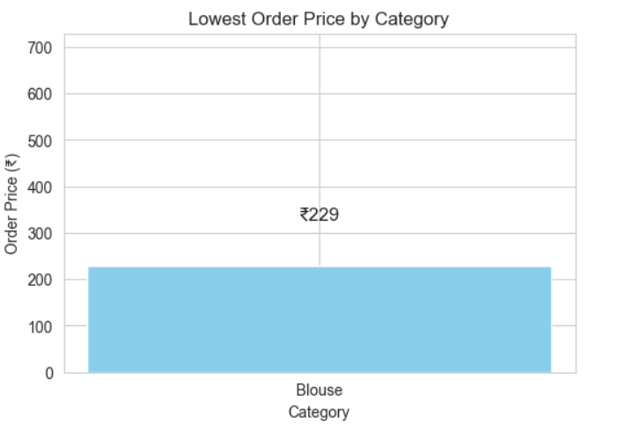Category: Blouse

Average Customer Spend per Transaction

Question: What is the average customer spend per transaction?

* 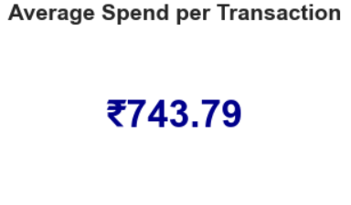 Average Spend: ₹743.79

Individual vs. Business Sales Distribution

Question: How many sales happened to Individual Customers versus Businesses?

* Individual Customers: 99.4% of total sales
* 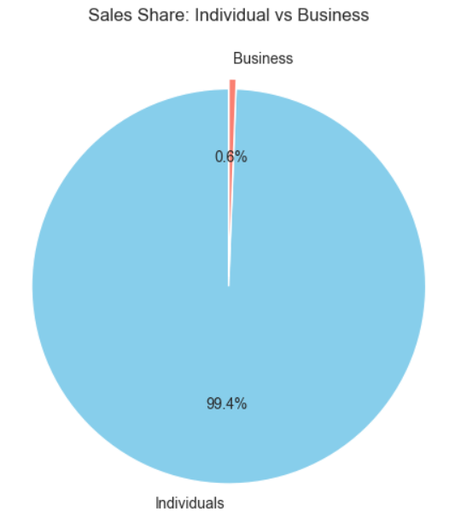Business Transactions: 0.6% of total sales

Insights

* The vast majority of sales come from retail consumers rather than businesses.
* Businesses contribute a very small portion of sales, indicating a primarily B2C (Business-to-Consumer) model.
* If expanding B2B (Business-to-Business) sales is a goal, strategies like bulk order discounts, business loyalty programs, and targeted marketing campaigns for corporate buyers could be effective.

Average spends per transaction by age group

Question: Which age group spends the most per order?

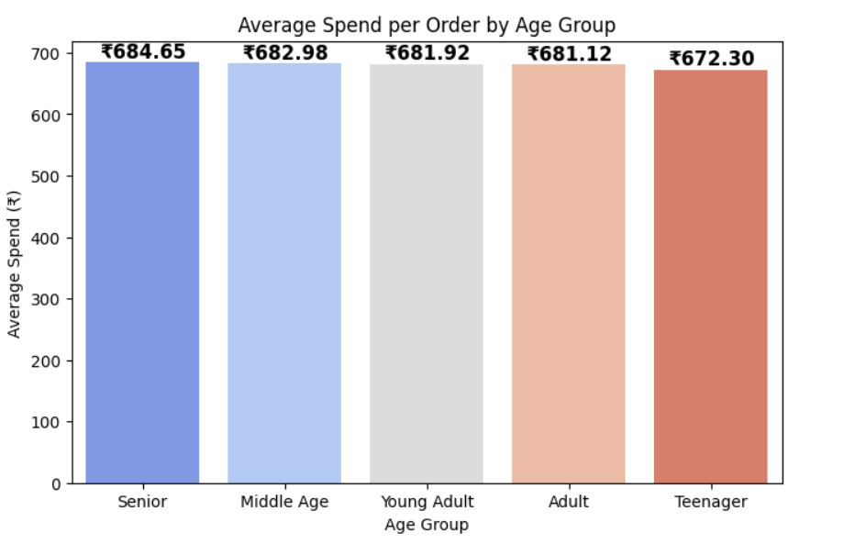

Average Order Value by Gender

Key Findings on Average Order Value (AOV) by Gender

* Men Spend More Per Transaction
* The Average Order Value (AOV) for Men is ₹801.94, while for Women, it is ₹629.28.
* This means that, on average, men spend 27% more per transaction than women.

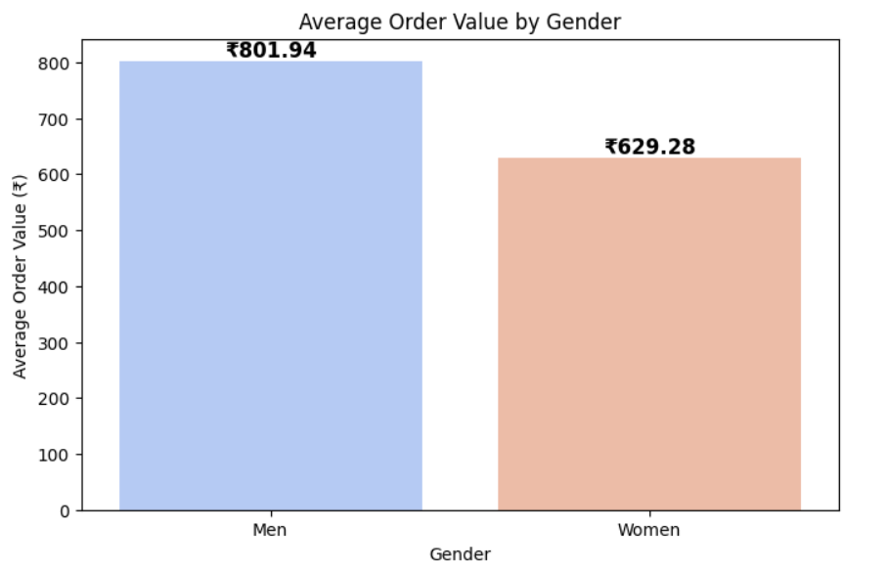

Which city has the highest number of repeat customers?

* Bengaluru

Return Customers: 22

* + 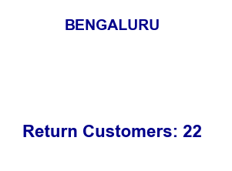Bengaluru has the highest number of return customers, with a total of 22. This indicates a strong customer retention rate in the city, suggesting that these customers continue to engage with the business.

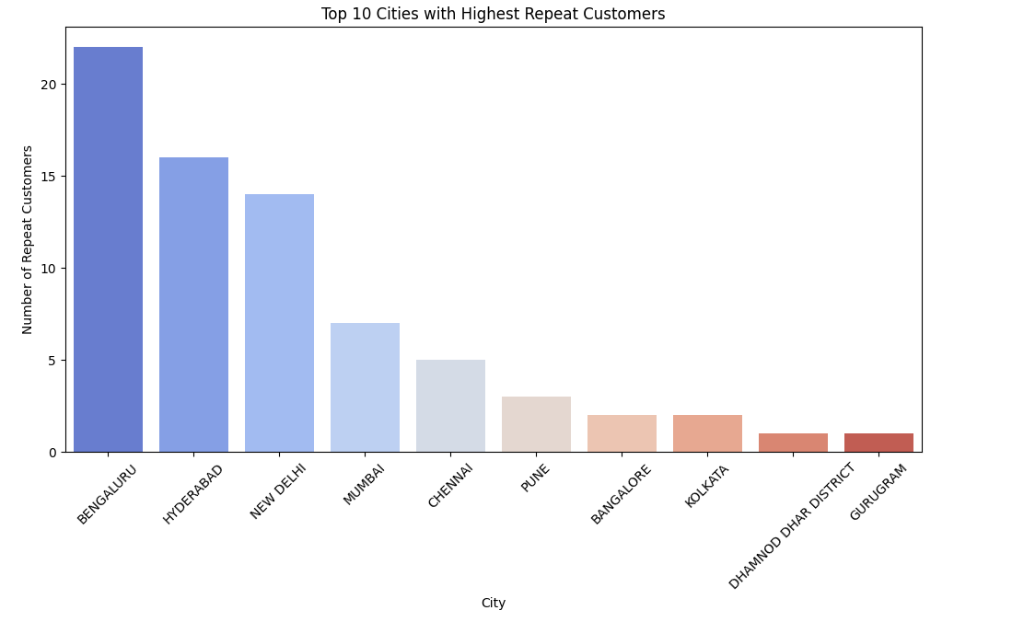

Key Insights:

* Strong Customer Retention: The fact that Bengaluru leads with 22 return customers highlights the importance of repeat business and customer loyalty.

Customer Order Analysis

Question: How many unique customers placed orders more than once?

Overview:

* Number of Unique Customers Who Placed Orders More Than Once: 2,093
  + This indicates that 2,093 customers made multiple purchases, showing a level of repeat business and customer retention.
* Single Order Count: 26,344
  + These represent customers who placed only one order. This suggests a large number of one-time customers who may need further engagement to become repeat buyers.
* Repeat Order Count: 2,093
  + These are the customers who made more than one purchase, showcasing a loyal customer base.

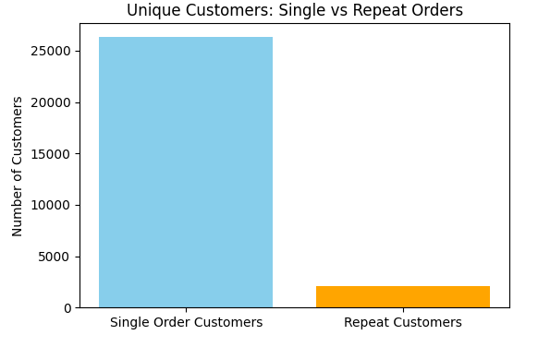

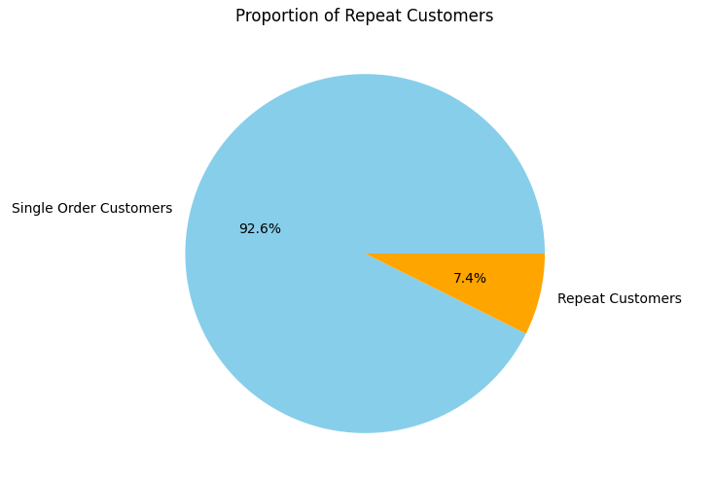

Key Insights:

* Customer Retention: Out of the total customer base, 2,093 unique customers placed more than one order, which indicates a healthy level of repeat business.
* One-Time Orders: A significant number of customers, 26,344, made a single purchase. This presents an opportunity to focus on increasing repeat orders and converting one-time customers into regular buyers.

Sales Trend by Product Category: Analysis

Question: Which category has highest growth trend over time?

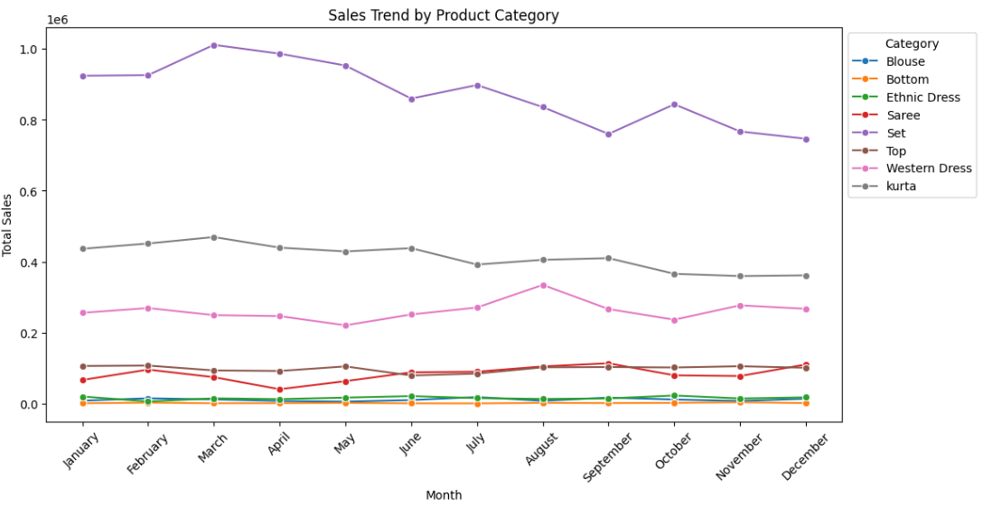

Conclusion

This report aimed to analyze sales data, customer behaviour, and trends across different categories and months. It focused on identifying key metrics such as the average spend per transaction, the number of repeat customers, and the sales growth trends by product category. Additionally, the goal was to uncover actionable insights that can help optimize sales strategies and improve customer retention.

Key Insights and Their Impact on Business Decisions:

1. Average Spend per Transaction: The average spends of ₹743.79 per transaction reflects healthy purchasing behaviour and indicates the potential for further growth by encouraging customers to make larger purchases. This insight can drive pricing strategies and product bundling opportunities to boost revenue.
2. Return Customers: With 22 return customers in Bengaluru, it is clear that repeat business plays a crucial role in the overall sales performance. The significant number of return customers suggests that strengthening loyalty programs and personalized marketing efforts can enhance customer retention and lead to higher sales volumes.
3. Growth Trend by Product Category: The sales trend analysis revealed which product categories experienced the highest growth over time. Understanding which categories are thriving can guide inventory management, targeted marketing, and product promotions to capitalize on these growth opportunities.
4. Single vs. Repeat Orders: The comparison of single-order customers (26,344) versus repeat-order customers (2,093) highlights a substantial opportunity for increasing customer loyalty and converting one-time buyers into regular customers through strategic initiatives such as follow-up offers, discounts, and tailored communication.

Impact on Business Decisions:

* Marketing Strategy: The insights into repeat customers and high-growth categories allow the business to tailor marketing efforts towards retaining customers and promoting the most successful product categories.
* Customer Engagement: Emphasizing customer retention strategies, such as loyalty programs and targeted outreach, can increase the number of return customers, thereby boosting revenue.
* Inventory and Product Management: Identifying high-growth categories helps in optimizing stock levels and planning product launches to meet demand efficiently.

Appendix: Charts and Graphs

* Most Popular Category
  + 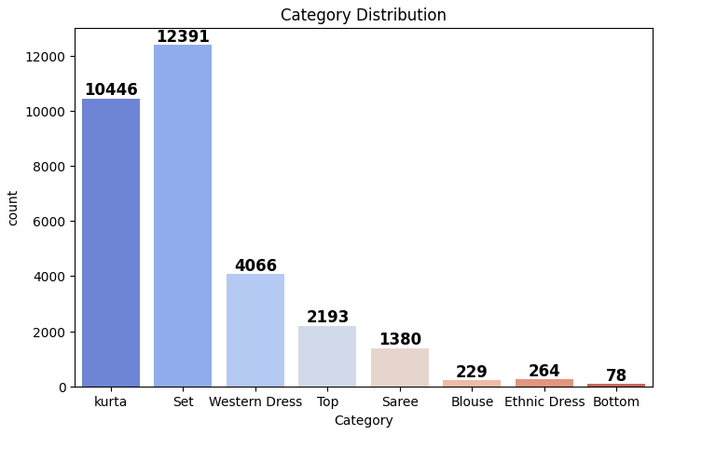Description: A bar chart showcasing the most popular product category based on total sales.
* Most Popular Sizes
* Description: A chart displaying the most popular sizes based on the count of orders placed for each size.

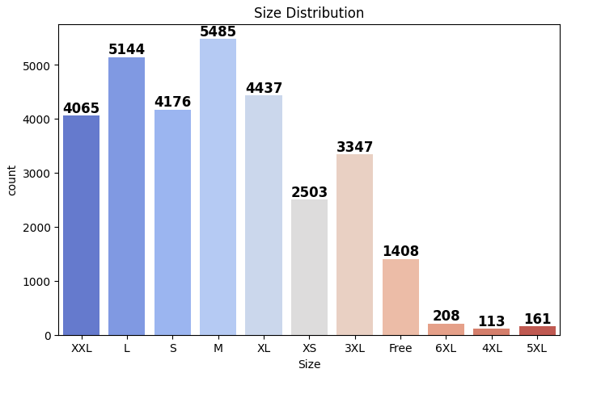

Most Popular States

* Description: A chart showing the most popular states based on the number of orders placed from each state.

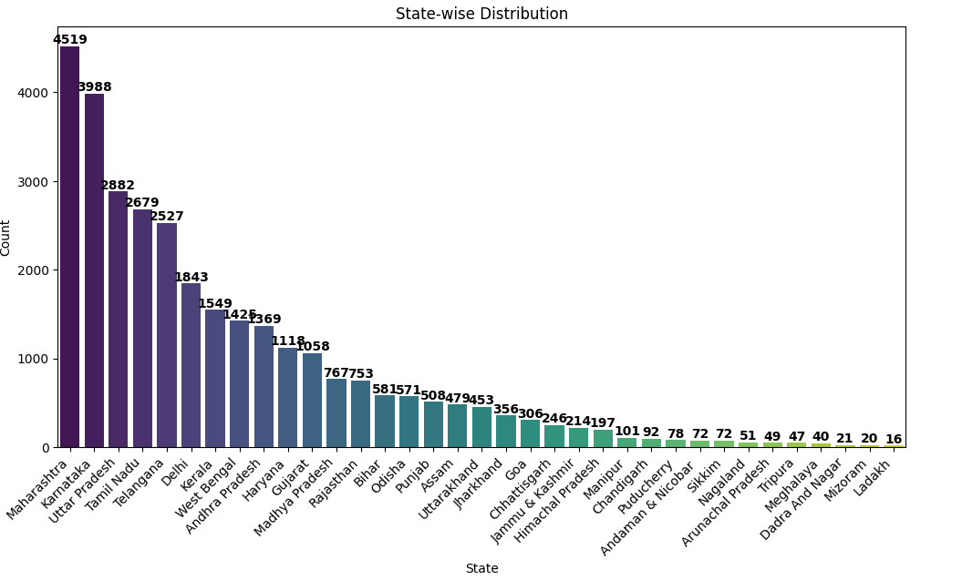

Top 10 Most Popular SKUs

* Description: A chart displaying the top 10 most popular Stock Keeping Units (SKUs) based on the total number of units sold.

